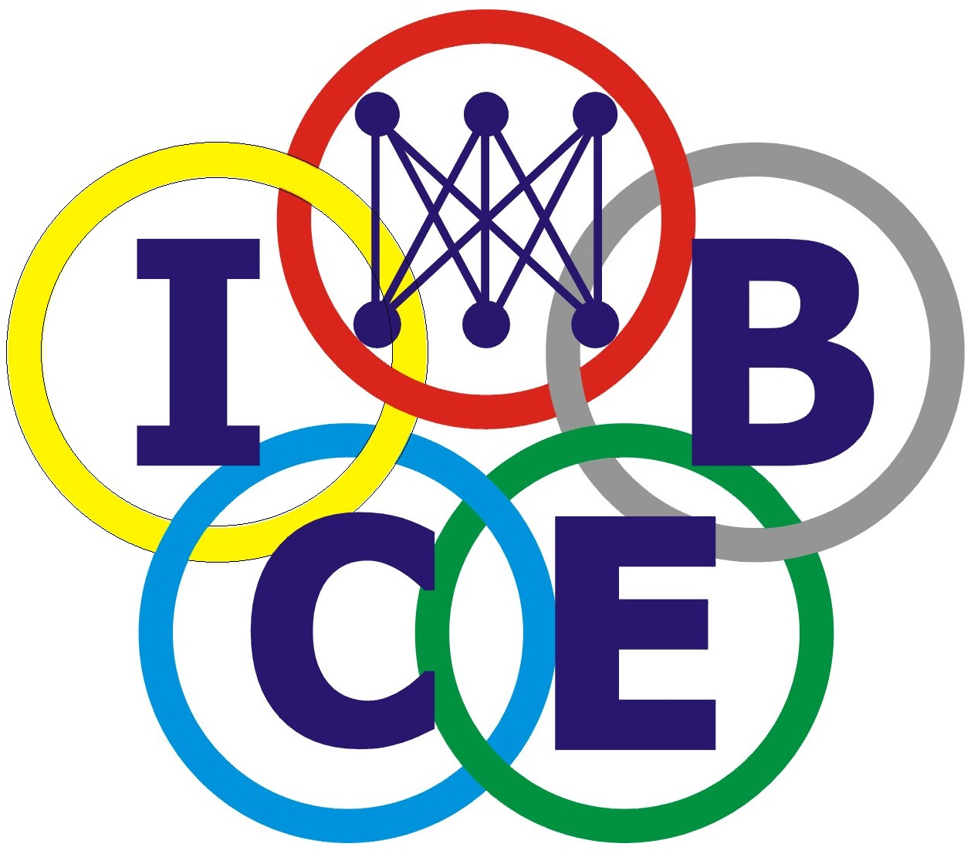
INTERNATIONAL CONSORTIUM FOR ELECTRONIC BUSINESS
The 23rd International Conference on Electronic Business
Chiayi, Taiwan, 19 - 23 OCT 2023

REGISTRATION FORM USING ACCUPASS
(For participants who use the payment gate in TWD currency only.)

All attendees must register for the meeting. The completed registration form must be received by SEP. 25, 2023 to receive the discount of US$50. Please send a copy of the payment receipt and this completed registration form to eli@calpoly.edu using the Subject text of “ICEB 2023 Registration”. You will receive a confirmation email within 2 working days.

If you submitted papers to this conference, what are your Paper IDs? ________/_________/__________
Are you a presenter? □Yes □No (If No, who is the presenter? Name: _______________________________)

REGISTRANT INFORMATION:
_______________________________ _____________________________________
Last/Family Name (Please Print) First Name & Middle Initial (Please Print)

Affiliation (University/Company): _______________________________ Tax ID: ___________________

Department: _____________________________________________________________________________

MAILING ADDRESS:
______________________________________________________________________________________________________
Street
______________________ _____________________ ___________________ _____________________
City State/Province Zip/Postal Code Country
__________________________________________________ _____________________________________________
Email address Telephone Number (Country code/Area code/Tel. No.)
_________________________________________________ _____________________________________________
Mobile Phone Number Fax Number (Country code/Area code/Tel. No.)

Did you reply to the Pre-Conference Survey Form sent to you by the Conference Chair earlier via EasyChair?
______ Yes / ______ No
If No, please visit https://iceb2023.johogo.com/2023-PCSF.htm and complete the survey. Many thanks!!!

Paper Information (Maximum 3 papers for each author; skip if you are not an author.)
Paper ID | Paper Title (State the first few words of the title) | Oral Presentation? *
 |  | □
 |  | □
 |  | □
*At least one author must register and present the paper.

For active ICEB/AIS members, please indicate your ID to qualify for the member rate:
AIS member, please provide your membership ID here ______________________________.
ICEB member, please confirm that your name is listed at https://iceb.johogo.com/ICEBMemberList.htm.
□ I am an ICEB active member; my name is listed as #_______. □ I am a non-member; my name is not listed.
Registration Fees* # |  | Early-bird price  (Before SEP. 25, 2023) | Regular price  (On or After SEP. 25, 2023) |  | Subtotal
1 | Member Presentation (Regular)* | US$100 per person | US$150 per person |  | US$
2 | Member Presentation (Student)* | US$50per person | US$100 per person |  | US$
3 | Non-member** Presentation (Regular)* | US$150 per person** | US$200 per person** |  | US$
4 | Non-member** Presentation (Student)* | US$75 per person** | US$125 per person** |  | US$
5 | Additional Paper Charge # | US$50 per extra title for authors with multiple paper presentations. |  |  | US$
6 | Publication Fee (for post-conference formal proceedings book) | US$200 for each title of full paper or WIP paper. However, abstract is not qualified. ^ |  |  | US$
7 | Physical Mode Activity Fee (to attend on site events) @ | US$200 for each person ^ |  |  | US$
8 | On-site Guest (Non-author)@ | US$300 per person,  includes 2023 and 2024 memberships |  |  | US$
9 | Off-site Virtual Guest (Non-author) | US$40 (Regular) or US$20 (Student),  includes 2023 and 2024 memberships |  |  | US$
10 | Pay the 2023 Membership Fee to qualify for the Member rate.** | □ Regular member US$ 20 ^  □ Student member US$ 10 ^ |  |  | US$
11 | Pay the 2024 Membership Fee. | □ Regular member US$ 20 ^  □ Student member US$ 10 ^ |  |  | US$
Grand Total: |  |  |  | US$
Please enter ACCUPASS FID Code(s): A/B/C/D ___, L, F
(Grand Total +5% surcharge) × NT$31 = ACCUPASS Total: |  |  |  | NT$
NOTE FOR REGISTRATION FEE:
^ This fee will be transferred to ICEB Home Office to cover part of the needed expenses.
* There are three types of registration fees: Presentation Fee (required), Publication Fee (optional), and Physical Mode Activity Fee (optional). The presentation fee (be it regular or student) allows you to get a name badge (virtually or printed) to attend all presentation sessions virtually (including technical sessions, keynote sessions), list one title on the Program Book and the informal proceedings Zip file. However, if you want to be physical on site, you must pay the Physical Mode Activity Fee of US$200. The presentation fee also includes the membership dues of US$20 per regular registrant and US$10 per student and will be transferred to ICEB Home Office according to the constitution. In addition, if you want to publish your paper in the EI-Compendex+Scopus double indexed formal post-conference electronic proceedings book, you must pay the publication fee of US$200 per paper. Finally, for a co-authored paper, only after a co-author registers at the regular rate, the others (regardless of regular or student member) can register as students.
** Please check the membership directory at https://iceb.johogo.com/ICEBMemberList.htm to find out whether you are an ICEB 2023 active member. If you are not a member, you could select to pay for the 2023 membership fee and then select "Member On-site Presentation" option to pay the fee. Co-authors presenting the paper must also pay for the presentation fee. For example, if a professor is a registrant and his/her student is presenting the paper, the student also needs to pay for the presentation fee to get a name badge. No badge, no presentation is allowed
# Each paper must pay a presentation fee. The corresponding author with multiple papers must pay for one presentation fee and present one paper free. The 2nd and 3rd papers must pay the extra paper charge of US$50 each. A corresponding author can pay for and present up to 3 papers at the conference.
@ Each author on site must pay the Physical Mode Activity Fee of US$200 to get a name badge and meeting materials, and FREE admission to 6 coffee breaks, 3 lunches, 3 dinners, and 1 industry visit. To present a paper on site, the presenter must pay for the Physical Mode Activity Fee and the Presentation Fee to get a name badge. No badge, no presentation!
PAYMENT METHOD
Please pay by an international credit card via the payment gateway of ACCUPASS, following the instructions at https://iceb2023.johogo.com/Gateway.php. The ACCUPASS has a 5% surcharge, and the USD fee above will be exchanged into TWD (NT$) with a fixed rate of US$1=NT$31.

Student Registration: Please provide the scanned images of the student ID or any proof of the student status.
(Front) | (Back)

